B. Data MANIPULATION Languages (DML)
1.Perform UNION of customers and employees relation. (i.e. only matching attributes) Query:

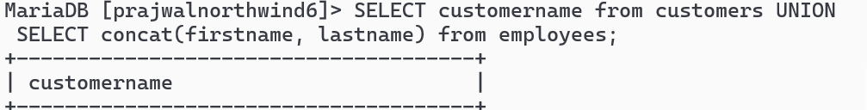

2.Perform UNION ALL of customers.contactname and employee.fullname
Query:

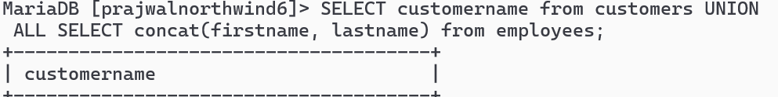
3.List all customers from Mexico and Austria using UNION.
Query:

4.List all customers of USA not having same name as of customers from UK
Query:

5.Create view cust by selecting only 4 attributes from customers.
Query:

6.Products with Categories and Suppliers to create a view named productinfo with productID, Name,Unit, Price from products and all attributes from categories and suppliers.
Query:

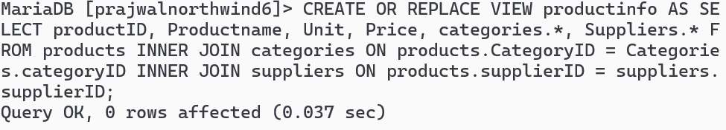

7.Find name and count of Categories from productinfo.
Query:

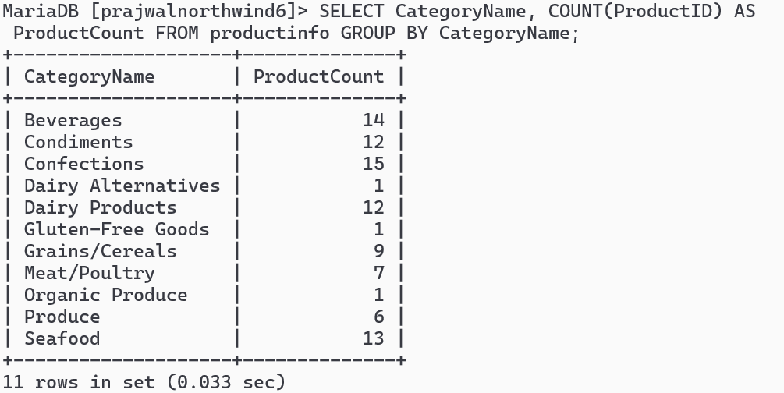
8. Find all products that have suppliers from North America in productinfo Query:
9.Find all products that have price lower price than Average price from productinfo.
Query:

10.Join orders with customers, employees and shippers to create a view as orderinfo.
Query:

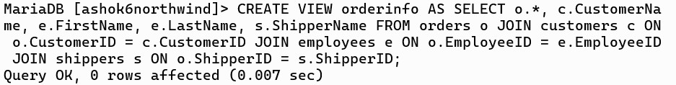
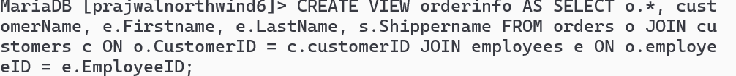

11.List all order shipment provided by United Package and Swift Shipping from orderinfo
Query:

12.List all order processed by employee Janet Leverling and Steven Buchanan from orderinfo
Query:

s

13.List all order shipment provider on date august 18 2023 from orderinfo Query:

14.List countries of customers that placed order on august 19 2023 from orderinfo
Query:
